Problem Solving Techniques and Data Structures – II
SET 1 – E-COMMERCE CATALOGUE AND TRAFFIC ANALYSIS
Business Scenario:
An e-commerce platform wants faster category browsing, instant SKU look-ups and a way to size infrastructure for peak traffic.
Task 1: Build a Binary Search Tree of Product Categories
Pseudocode Implementation:
INSERT(root, value)
IF root is NULL
RETURN new Node(value)
IF value < root.value
root.left = INSERT(root.left, value)
ELSE IF value > root.value
root.right = INSERT(root.right, value)
RETURN root

SEARCH(root, target)
IF root is NULL OR root.value = target
RETURN root
IF target < root.value
RETURN SEARCH(root.left, target)
RETURN SEARCH(root.right, target)

INORDER(root)
IF root is NOT NULL
INORDER(root.left)
PRINT root.value
INORDER(root.right)

PREORDER(root)
IF root is NOT NULL
PRINT root.value
PREORDER(root.left)
PREORDER(root.right)

POSTORDER(root)
IF root is NOT NULL
POSTORDER(root.left)
POSTORDER(root.right)
PRINT root.value
Explanation
A Binary Search Tree (BST) is a hierarchical data structure where each node stores a value, with left descendants holding smaller values and right descendants holding larger values.
• Insertion: Recursively locates the appropriate leaf position to insert new product categories in ordered sequence.
• Searching: Compares the search target with the current node value to traverse down either the left or right subtree.
• Inorder Traversal: Visits Left -> Root -> Right subtrees, outputting category names in sorted alphabetical order.
• Preorder Traversal: Visits Root -> Left -> Right subtrees, which is useful for cloning or serializing the tree structure.
• Postorder Traversal: Visits Left -> Right -> Root subtrees, useful for bottom-up node processing or deletion.
Binary Search Tree Diagram
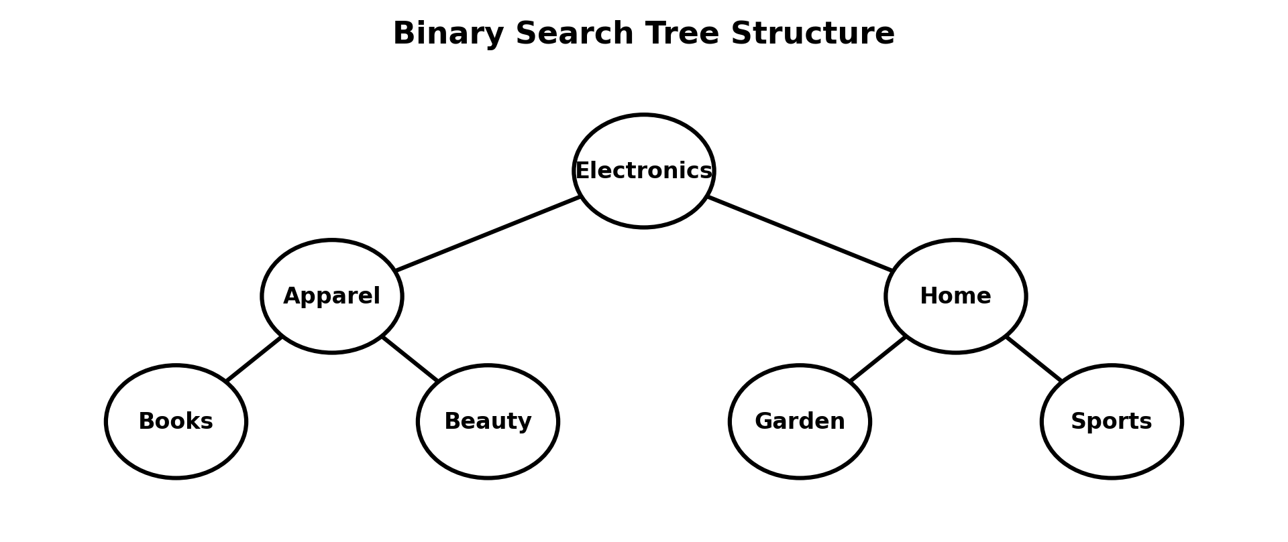
Complexity Analysis: Average insertion and search time complexity is O(log n). Worst-case complexity degrades to O(n) if categories are inserted in pre-sorted order forming a skewed tree. Traversal complexity is O(n) as every node is visited once.
Task 2: Implement a Small Hash Table with Chaining for SKU Look-up
Pseudocode Implementation:
HASH(key, tableSize)
RETURN key MOD tableSize

INSERT(table, key, value)
index = HASH(key, tableSize)
ADD (key, value) TO table[index]

SEARCH(table, key)
index = HASH(key, tableSize)
FOR EACH entry IN table[index]
IF entry.key = key
RETURN entry.value
RETURN NOT_FOUND

MAIN
CREATE hash table with 10 buckets
INSERT(101, "SKU-A")
INSERT(111, "SKU-B")
SEARCH(111)
Collision Demonstration
A hash collision occurs when two distinct keys yield the identical hash index after passing through the modulo hashing function.
Demonstration Example: Keys 101 and 111 with a bucket table size of 10 produce 101 % 10 = 1 and 111 % 10 = 1. Both keys map directly to index 1 and are linked together sequentially in bucket 1.
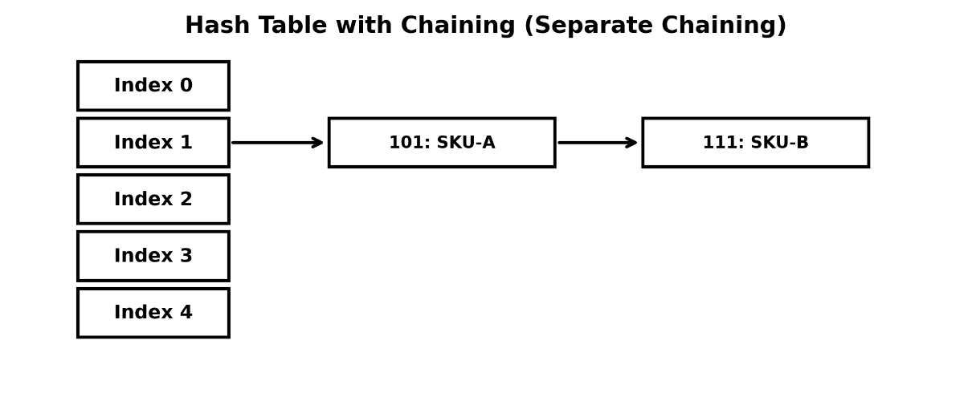
Hash Table Diagram

Explanation:
Hashing converts SKU keys into integer indices for constant-time direct memory access. When hash collisions occur, separate chaining resolves them by converting each table bucket into a linked list of key-value pairs.
Standard built-in HashMaps manage dynamic resizing, hashing, and collision resolution internally. For a dataset of 100,000 SKUs, look-up times can be benchmarked across custom chaining and built-in map structures.
Implementation Comparison
Feature | Custom Hash Table | Built-in HashMap
Implementation | Manual Chaining | Built-in Framework
Collision Handling | Separate Linked Lists | Internal Chaining / Treeification
Average Lookup | O(1) | O(1)
Maintenance Overhead | Manual pointer management | Automated

Complexity Analysis: Average look-up complexity is O(1). Worst-case lookup is O(n) if all keys hash into a single bucket list.
Task 3: Model Microservice Deployment Dependencies as a Graph
Pseudocode – BFS Topological Sorting:
TOPOLOGICAL_SORT(graph)
Calculate indegree of every vertex
CREATE empty queue
ADD all vertices with indegree 0 to queue
CREATE empty deploymentOrder
WHILE queue is not empty
current = REMOVE_FRONT(queue)
ADD current TO deploymentOrder
FOR EACH neighbour OF current
Decrease indegree of neighbour
IF indegree of neighbour = 0
ADD neighbour TO queue
IF deploymentOrder size != number of vertices
PRINT "Circular dependency detected"
ELSE
PRINT deploymentOrder
Pseudocode – DFS Cycle Detection:
DFS(node)
MARK node as VISITING
FOR EACH neighbour OF node
IF neighbour is VISITING
RETURN TRUE
IF neighbour is NOT VISITED
IF DFS(neighbour) = TRUE
RETURN TRUE
MARK node as VISITED
RETURN FALSE
Graph Dependency Diagram
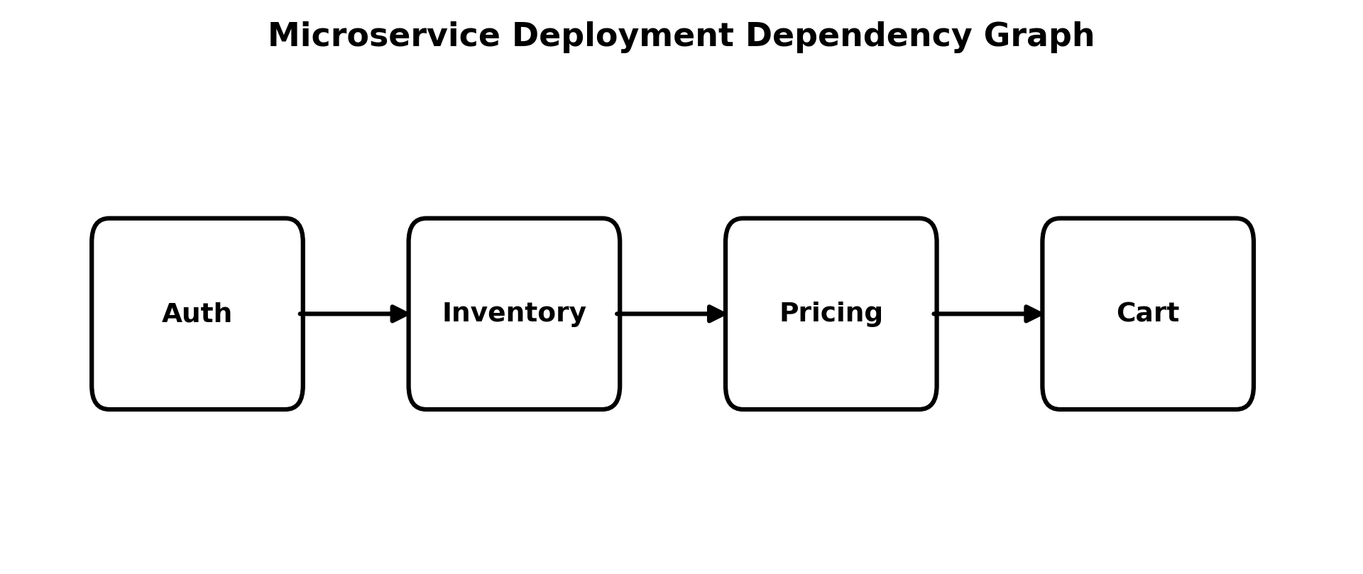
Explanation
Microservice architecture dependencies are modelled as directed graphs where vertices represent microservices and directed edges represent explicit startup prerequisites.
BFS Topological Sorting (Kahn's Algorithm) calculates vertex in-degrees to evaluate readiness and outputs a valid linear execution sequence. DFS cycle detection tracks current recursion call stacks to flag circular dependencies that would break automated deployment.
Deployment Example: Inventory -> Pricing -> Cart indicates Inventory must complete initialization prior to Pricing starting, followed by Cart.
Complexity Analysis: Time and Space Complexity for graph traversal algorithms is O(V + E), where V is total microservices and E represents dependency links.
Task 4: Find the Busiest Continuous 3-Hour Window Using Sliding Window
Pseudocode Implementation:
BUSIEST_WINDOW(requests)
IF length(requests) < 3
RETURN "Insufficient data"
windowSum = sum of first 3 elements
maxSum = windowSum
bestStart = 0
FOR i = 3 TO length(requests) - 1
windowSum = windowSum + requests[i] - requests[i - 3]
IF windowSum > maxSum
maxSum = windowSum
bestStart = i - 2
RETURN bestStart, maxSum
Sliding Window Diagram
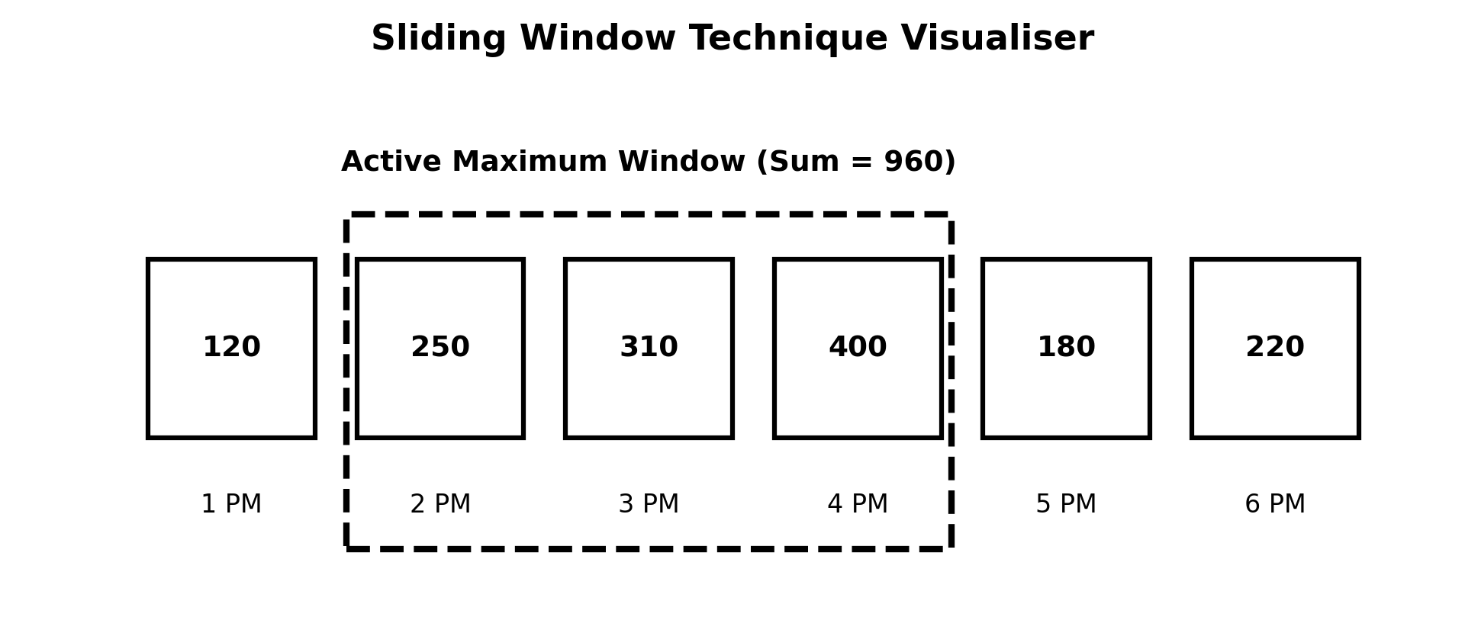
Explanation
The Sliding Window algorithm evaluates contiguous sub-arrays in a linear pass. By computing the sum of the first 3 consecutive hours, subsequent windows are calculated by adding the incoming hourly value and subtracting the trailing hourly value.
This avoids nested loop re-computation of full window sums across time series datasets.
Complexity Analysis: Time Complexity: O(n) linear single pass. Space Complexity: O(1) auxiliary space.
Task 5: Use Two Pointers to Find Pairs That Add Up to a Gift-Card Value
Pseudocode Implementation:
FIND_PAIRS(values, target)
left = 0
right = length(values) - 1
WHILE left < right
sum = values[left] + values[right]
IF sum = target
PRINT values[left], values[right]
left = left + 1
right = right - 1
ELSE IF sum < target
left = left + 1
ELSE
right = right - 1
Example Run: Values = [10, 20, 30, 40, 50], Gift Card Target = 60. Output Pairs: (10, 50) and (20, 40).
Two Pointers Diagram
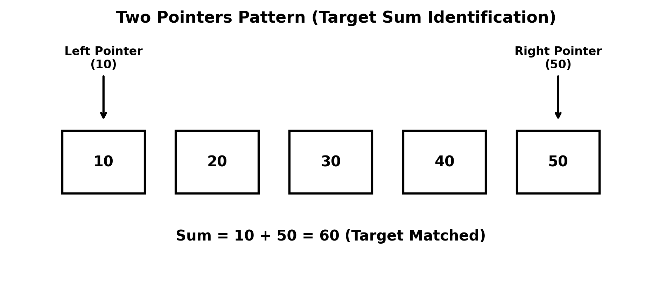
Explanation
The Two-Pointer approach operates on sorted numeric arrays. A left pointer starts at index 0 and a right pointer starts at index n-1. Depending on whether the computed sum is smaller or larger than the target, pointers increment or decrement towards the center.
Complexity Analysis: Time Complexity: O(n) pass on pre-sorted input. Space Complexity: O(1) auxiliary space.
SET 2 – INSURANCE CLAIMS PROCESSING
Business Scenario:
An insurer must route claims through approval stages, detect duplicate claim submissions and monitor claim spikes after a regional event.
Task 1: Create a BST of Claim IDs
Pseudocode Implementation:
INSERT(root, claimID)
IF root is NULL
RETURN new Node(claimID)
IF claimID < root.value
root.left = INSERT(root.left, claimID)
ELSE IF claimID > root.value
root.right = INSERT(root.right, claimID)
RETURN root

SEARCH(root, claimID)
IF root is NULL OR root.value = claimID
RETURN root
IF claimID < root.value
RETURN SEARCH(root.left, claimID)
RETURN SEARCH(root.right, claimID)

INORDER(root)
IF root is NOT NULL
INORDER(root.left)
PRINT root.value
INORDER(root.right)

PREORDER(root)
IF root is NOT NULL
PRINT root.value
PREORDER(root.left)
PREORDER(root.right)

POSTORDER(root)
IF root is NOT NULL
POSTORDER(root.left)
POSTORDER(root.right)
PRINT root.value
Explanation & Sorted Traversal Answer
Claim IDs are organized within a BST structure to maintain ordered data access.
Which traversal gives claims in sorted order? Inorder traversal produces claim IDs in strict sorted ascending order because it systematically processes the entire left subtree (smaller IDs), visits the current node, and then processes the right subtree (larger IDs).

BST Diagram
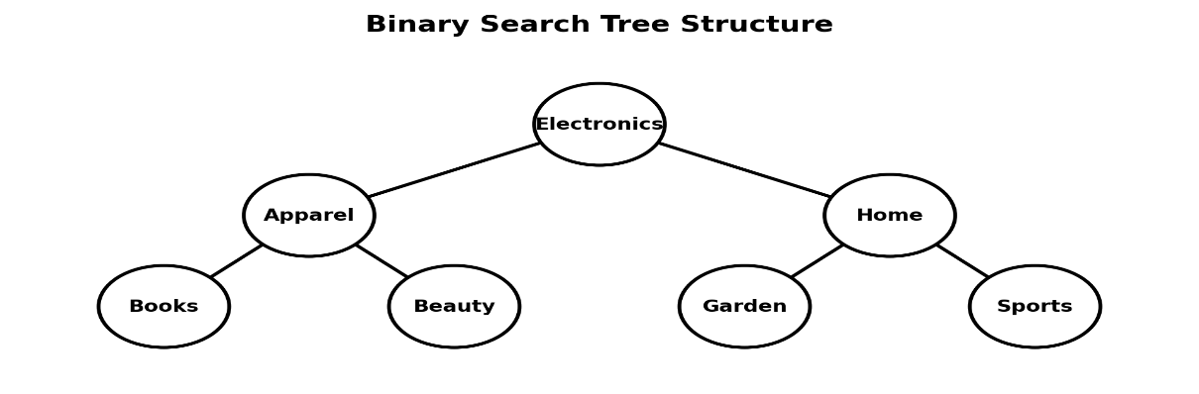
Complexity Analysis: Average insert/search complexity: O(log n). Worst-case complexity: O(n). Traversal complexity: O(n).
Task 2: Use Hashing to Detect Duplicate or Near-Duplicate Claims
Pseudocode Implementation:
NORMALIZE(value)
Remove leading and trailing spaces
Convert all letters to lowercase
Remove unnecessary internal spaces
RETURN value

DETECT_DUPLICATES(claims)
CREATE empty HashSet
FOR EACH claim IN claims
policy = NORMALIZE(claim.policyNumber)
date = NORMALIZE(claim.incidentDate)
key = policy + "|" + date
IF key EXISTS IN HashSet
PRINT "Duplicate claim detected"
ELSE
ADD key TO HashSet
Explanation & Collision Handling Answer
Claim text fields are cleaned and normalized to strip casing and whitespace variances. Composite unique string keys are generated by joining normalized policy numbers and incident dates.
How are collisions handled? Collisions occur when two non-identical composite keys generate identical hash bucket indices. Hash collections handle collisions internally by bucket chaining and evaluating full key equality via equality comparisons. A collision alone does not signify a duplicate claim.
Complexity Analysis: Time Complexity: O(n) average processing time. Space Complexity: O(n) hash set storage.
Task 3: Model Claim Approval Stages as a Directed Graph
Pseudocode – BFS Shortest Path:
BFS(graph, start, destination)
CREATE empty queue
ADD start TO queue
MARK start as visited
parent[start] = NULL
WHILE queue is not empty
current = REMOVE_FRONT(queue)
IF current = destination
RETURN BUILD_PATH(parent, destination)
FOR EACH neighbour OF current
IF neighbour is NOT visited
MARK neighbour as visited
parent[neighbour] = current
ADD neighbour TO queue
RETURN "No path exists"
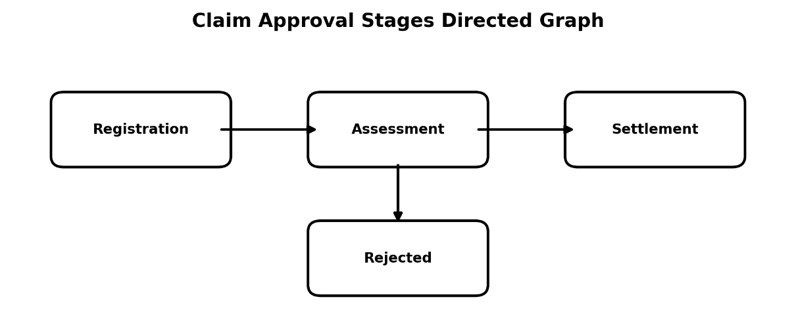
Pseudocode – DFS Loop Detection:
DFS(node)
MARK node as VISITING
FOR EACH neighbour OF node
IF neighbour is VISITING
RETURN TRUE
IF neighbour is NOT VISITED
IF DFS(neighbour) = TRUE
RETURN TRUE
MARK node as VISITED
RETURN FALSE
Claim Approval Graph Diagram

Explanation
Workflow stages (Registration, Assessment, Surveyor, Settlement) form nodes in a directed graph.
BFS determines the shortest route through processing stages. DFS detects cyclical processing loops by identifying back-edges leading to nodes currently in the active recursive visiting state.
Complexity Analysis: Time Complexity for BFS and DFS graph traversals: O(V + E).
Task 4: Find the Longest Run of Consecutive Days on Which Claims Exceeded 100
Pseudocode Implementation:
FIND_LONGEST_RUN(claimCounts)
bestLength = 0
currentLength = 0
bestStart = -1
currentStart = -1
FOR i = 0 TO length(claimCounts) - 1
IF claimCounts[i] > 100
IF currentLength = 0
currentStart = i
currentLength = currentLength + 1
IF currentLength > bestLength
bestLength = currentLength
bestStart = currentStart
ELSE
currentLength = 0
currentStart = -1
RETURN bestStart, bestLength
Example Run: Daily Claims = [120, 150, 130, 90, 110, 140, 160]. First streak (120, 150, 130) length = 3. 90 breaks the streak. Next streak (110, 140, 160) length = 3. Maximum consecutive streak = 3 days.
Explanation
The algorithm maintains a running counter tracking contiguous sequences where daily claim counts strictly exceed 100. Any count of 100 or below resets the active counter.
Complexity Analysis: Time Complexity: O(n) single scan. Space Complexity: O(1) auxiliary variables.

Task 5: Merge Two Sorted Claim Lists Using Two Pointers
Pseudocode Implementation:
MERGE(listA, listB)
i = 0
j = 0
CREATE empty mergedList
WHILE i < length(listA) AND j < length(listB)
IF listA[i] <= listB[j]
ADD listA[i] TO mergedList
i = i + 1
ELSE
ADD listB[j] TO mergedList
j = j + 1
WHILE i < length(listA)
ADD listA[i] TO mergedList
i = i + 1
WHILE j < length(listB)
ADD listB[j] TO mergedList
j = j + 1
RETURN mergedList
Example Input: List A = [10, 30, 50], List B = [20, 40, 60]. Merged Result = [10, 20, 30, 40, 50, 60].
Merge Process Diagram
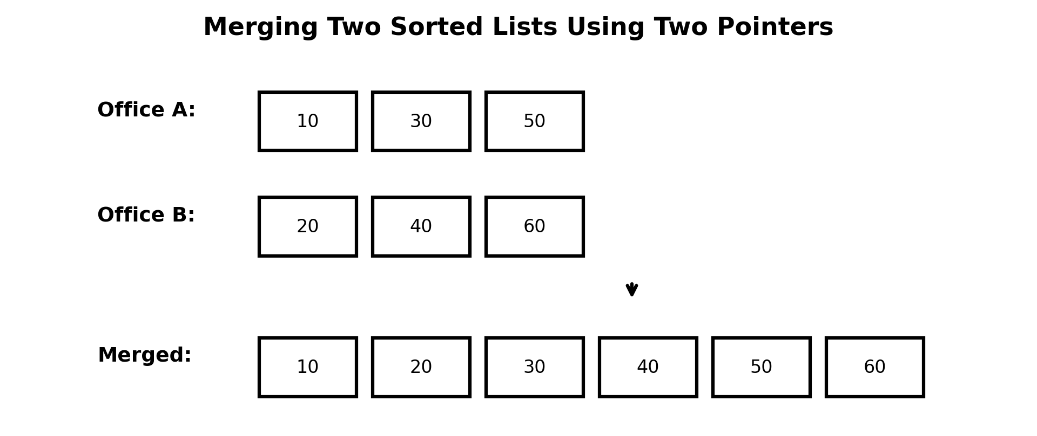
Explanation
Two array index pointers compare head elements of pre-sorted lists A and B. The smaller element appends to the target array and its pointer advances, merging sorted inputs in linear time without additional sorting calls.
Complexity Analysis: Time Complexity: O(m + n). Space Complexity: O(m + n) merged list storage.
SET 3 – LOGISTICS NETWORK AND DELIVERY WINDOWS
Business Scenario:
A courier company is optimising hub-to-hub routing and delivery-window planning across a national network.
Task 1: Store Hub Codes in a BST and Identify Tree Height
Pseudocode Implementation:
INSERT(root, hubCode)
IF root is NULL
RETURN new Node(hubCode)
IF hubCode < root.value
root.left = INSERT(root.left, hubCode)
ELSE IF hubCode > root.value
root.right = INSERT(root.right, hubCode)
RETURN root

SEARCH(root, target)
IF root is NULL OR root.value = target
RETURN root
IF target < root.value
RETURN SEARCH(root.left, target)
RETURN SEARCH(root.right, target)

HEIGHT(node)
IF node is NULL
RETURN -1
leftHeight = HEIGHT(node.left)
rightHeight = HEIGHT(node.right)
RETURN 1 + MAX(leftHeight, rightHeight)
Explanation & Skewed Tree Analysis
Tree height represents the maximum edge path length from root to leaf node. If sorted hub codes are inserted sequentially into an unbalanced BST, the tree degrades into a linear linked list (skewed tree) increasing height to O(n) and slowing lookup performance.
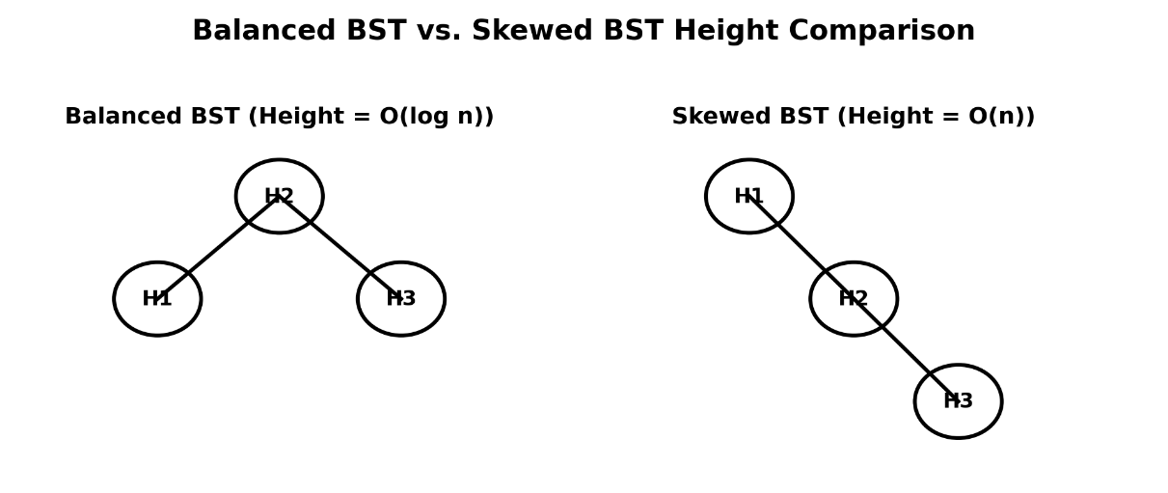
Balanced vs Skewed BST Diagram
Complexity Analysis: Balanced Tree Search/Insert: O(log n). Skewed Tree Search/Insert: O(n). Height calculation time: O(n).
Task 2: Build a Lookup of Parcel Tracking Numbers Using a HashMap
Pseudocode Implementation:
CHECK_DUPLICATE_SCANS(scanRecords)
CREATE empty HashSet
CREATE empty duplicatesList
FOR EACH scan IN scanRecords
key = scan.trackingNumber + "|" + scan.hubCode
IF key EXISTS IN HashSet
ADD scan TO duplicatesList
ELSE
ADD key TO HashSet
RETURN duplicatesList

LOOKUP_PARCEL(hashMap, trackingNumber)
IF trackingNumber EXISTS IN hashMap
RETURN hashMap[trackingNumber]
ELSE
RETURN NOT_FOUND
Example Scan Tracking Table
Tracking Number | Hub Code
TR101 | H1
TR102 | H2
TR101 | H1 (Duplicate Scan Detected)
TR103 | H3
Explanation
HashMaps associate unique tracking keys with parcel records for constant-time retrieving. Combining tracking number and hub code forms a composite key that flags redundant scan events at identical hubs.
Complexity Analysis: Average lookup: O(1). Average insert: O(1). Full scan list processing: O(n).
Task 3: Represent 10 Hubs and Their Direct Routes as an Adjacency List
Adjacency List Representation:
H1 -> H2, H3
H2 -> H1, H4, H5
H3 -> H1, H6
H4 -> H2, H7
H5 -> H2, H8
H6 -> H3, H9
H7 -> H4, H10
H8 -> H5
H9 -> H6
H10 -> H7
Pseudocode – BFS Shortest Route:
BFS(graph, start, destination)
CREATE empty queue
ADD start TO queue
MARK start as visited
parent[start] = NULL
WHILE queue is not empty
current = REMOVE_FRONT(queue)
IF current = destination
RETURN BUILD_PATH(parent, destination)
FOR EACH neighbour OF current
IF neighbour is NOT visited
MARK neighbour as visited
parent[neighbour] = current
ADD neighbour TO queue
RETURN "No route found"
Pseudocode – DFS Reachable Hubs:
DFS(node, graph, visited)
ADD node TO visited
FOR EACH neighbour OF node
IF neighbour is NOT visited
DFS(neighbour, graph, visited)

MAIN
CREATE empty visited set
DFS(centralDepot, graph, visited)
PRINT visited
Explanation
An adjacency list stores direct connections between logistics hubs. BFS computes routes with the fewest hub hops. DFS identifies all network hubs reachable from the main depot node.
Complexity Analysis: Graph algorithm time complexities: O(V + E).
Task 4: Find the 4-Hour Window with the Highest Average Using Sliding Window
Pseudocode Implementation:
HIGHEST_AVERAGE(counts)
IF length(counts) < 4
RETURN "Insufficient data"
windowSum = sum of first 4 elements
maxSum = windowSum
bestStart = 0
FOR i = 4 TO length(counts) - 1
windowSum = windowSum + counts[i] - counts[i - 4]
IF windowSum > maxSum
maxSum = windowSum
bestStart = i - 3
average = maxSum / 4
RETURN bestStart, average
Explanation
Sliding window calculates continuous 4-hour delivery averages. Adding new incoming values and subtracting outgoing values computes rolling window sums efficiently without redundant iterations.
Complexity Analysis: Time Complexity: O(n). Space Complexity: O(1).
Task 5: Check Whether a Delivery Route Description Is a Palindrome Using Two Pointers
Pseudocode Implementation:
CHECK_PALINDROME(route)
cleaned = REMOVE separators from route
CONVERT cleaned TO lowercase
left = 0
right = length(cleaned) - 1
WHILE left < right
IF cleaned[left] != cleaned[right]
RETURN FALSE
left = left + 1
right = right - 1
RETURN TRUE
Example: Input Route = H1-H2-H1. Cleaned = H1H2H1. Forward and reverse characters match perfectly -> Palindrome Verified.
Explanation
Two pointers evaluate cleaned route strings from opposite ends inward to confirm symmetric route sequences.
Complexity Analysis: Time Complexity: O(n). Space Complexity: O(n) for string normalization.

